12/5/2024

Roksana Blazejczyk

Eco Habit Tracker

GUI Application

Contents

1. Requirements Specification 2

Overview of the Project 2

Functional Requirements: 2

Non-Functional Requirements: 2

User Stories: 2

2.Design Specification 3

Screen 1: Welcome Screen 3

Screen 2: Habit Tracker 4

Screen 3: Additional Information 5

3. Pseudocode 6

4. ZIP Folder and JAR File 13

5. Testing 13

6. Deployment Instructions 15

Platform Requirements 15

Installation Instructions 15

# Requirements Specification

## Overview of the Project

I am creating a simple app to help people track their eco-friendly habits. The app will let users enter how often they do eco-friendly actions, calculate the benefits of their habits, and give them helpful feedback and tips to improve.

## Functional Requirements:

1. **User Input:** Users can type in how many times a week they do specific eco-friendly habits.
2. **Habit Display:** The app will show at least five eco-habits with pictures and descriptions (e.g., using a reusable bottle or bag).
3. **Impact Calculations:** The app will calculate the environmental benefits and any money saved based on the user’s input.
4. **Feedback Generation:** Users will see a personalized message about their progress and get hints to improve.
5. **File Saving:** The feedback message will be saved to a text file so the user can OUTPUT or share it later.

## Non-Functional Requirements:

1. **Easy to Use:** The app will have a simple design, making it easy for anyone to use.
2. **Good Performance:** The app will work quickly without lagging.
3. **Error Handling:** The app will handle mistakes (like invalid input) without crashing.
4. **Due date: 09/01/2025**

## User Stories:

1. “As a user, I want to enter how many times I do eco-friendly habits each week so I can track my impact.”
2. “*As a user I want to reset habit data weekly so I can start fresh and focus on new goals.”*
3. “As a user, I want to see a summary of my progress and benefits to stay motivated.”
4. “As a user, I want to save my feedback to a file so I can keep it for later.”
5. “As a user, I want feedback messages that celebrate my accomplishments and suggest small, realistic improvements to help me do better.”
6. “As a user, I want tips and facts about eco-friendly habits to appear on the feedback page so I can learn more about sustainability.”
7. “As a client, I want have theme-coloured interface.”
8. “As a client I want to be able to show my logo on every page.”

# 2.Design Specification

The application will feature a GUI for the user to work with.

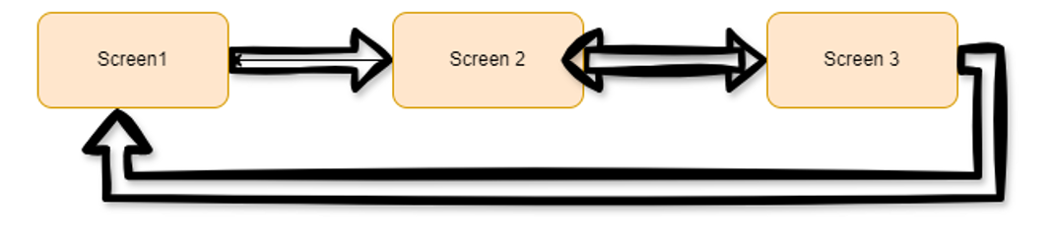

Figure User journey.



Figure 2 Colour Palette for GUI

## Screen 1: Welcome Screen

**Description:**

This screen displays the client’s logo and allows the customer to enter their name and age. The customer needs to enter a name and age to continue. It will be checked with validations for proper input from user’s side. When the next button is pressed application will move to next window.

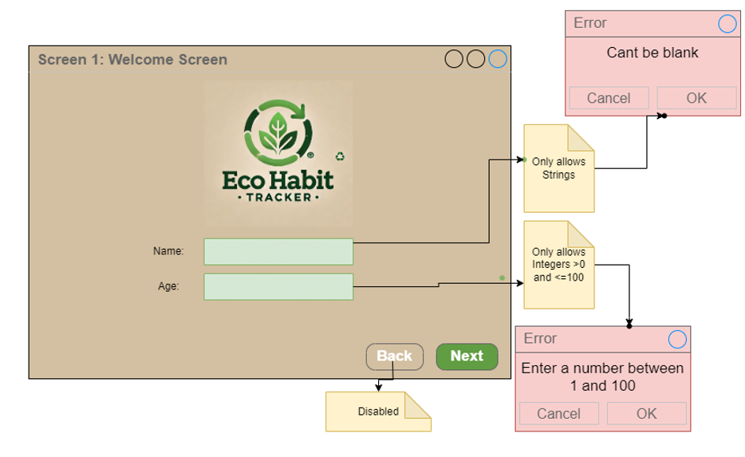

## Screen 2: Habit Tracker

**Description:**

This screen displays the client logo in top-left corner. On the left side of GUI there is 5 pictures with each Item and Dropdown menu button to chose the number from 0-7. At the bottom there is a Reset button which will reset the Summary, and Save button to save file to chosen location by user. Show Summary button which will lead to right side of the screen to show Summary of usage. Each summary will have different emoji icon depends on calculations. This side of the screen also show the user how much they saved per year, little motivation message and tips for make it better in future.

User also be able to go back to previous page when pressing “Back” and go to next page when pressing “Next”.

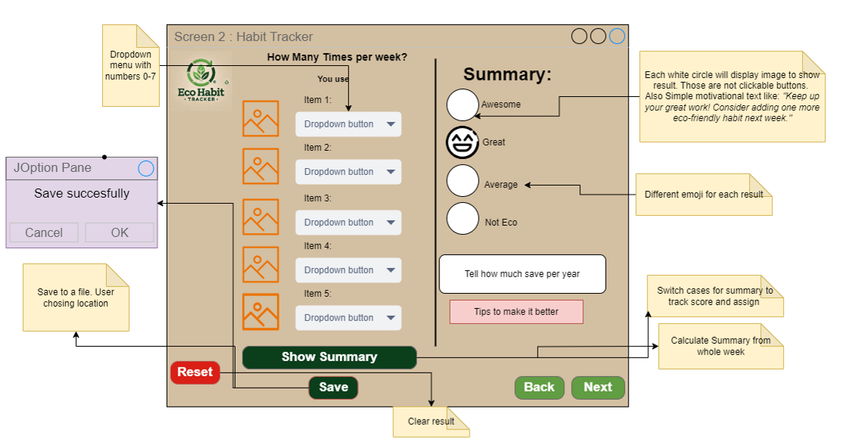

## Screen 3: Additional Information

**Description:**

This screen displays the client logo in top-left corner. Its also split in two parts. Left side shows 2 additional pictures of Items. Under each picture there is a slider to chose the number and text field to type the number it will be validated. Under those items there is a Show summary button which when pressed will display results on the right side of the GUI. I also added a fact which will calculate how many ££ user will save if he would swap from plastic bottle to reusable one for whole their current life.

Back button takes user to the previous screen, and Finish button when pressed will display a message if they would like to start again or terminate the program.

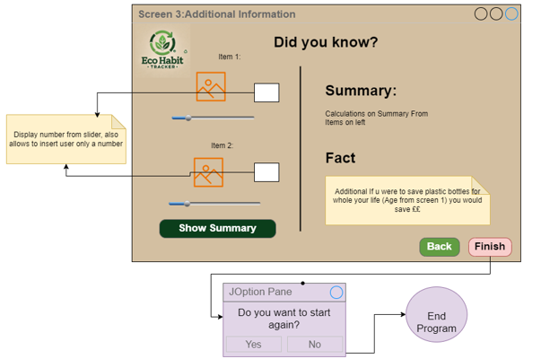

# 3. Pseudocode

#### Method for EcoTracker

SET avesomeLbl.setVisible(false);  
SET greatLbl.setVisible(false);  
SET averageLbl.setVisible(false);  
SET notEcoLbl.setVisible(false);  
SET awesomeBtn.setVisible(false);  
SET greatBtn.setVisible(false);  
SET averageBtn.setVisible(false);  
SET notEcoBtn.setVisible(false);

PRESS Back THEN

#### Method gotoPreviousScreen

PRESS Next THEN

#### Method gotoNextScreen

PRESS Summary THEN

#### Method showSummary

PRESS Reset THEN

#### Method resetForm

PRESS Save THEN

OUTPUT “Do you want to current list saved to file?”

IF OK THEN

WRITE summaryMessage

Flush

Close

OUTPUT “File saved Successfully”

ELSE

Nothing

PRESS Bulb Enter THEN

GET Value from Bulb Spinner

DOUBLE standardBulb = 1.29;  
DOUBLE ledBulb = 5.40;  
DOUBLE savingPerBulb = (20 * standardBulb) - ledBulb;

STRING textBulb

SET textBulb = “Benefits/Downsides”

DOUBLE totalSavings = outputBulb * savingPerBulb

STRING savingsMessage = String.*format*("Total savings for replacing %d bulbs: £%.2f", outputBulb, totalSavings);

SET bulbOutArea (savingsMessage + textBulb)

PRESS Paper Enter THEN

SET packUse as value from spinner

INT sheetsPack = 5000

INT sheetsTree = 10000

INT totalSheets = packUse * sheetsPack

INT treesChopped = (int) Math.*ceil*((double) totalSheets / sheetsTree);

SET textPaper = “Benefits/Downsides”

STRING resultMessage = String.*format*("Total sheets used: %,d\nNumber of trees chopped: %d", totalSheets, treesChopped)

SET paperOutArea (resultMessage + textPaper)

PRESS Fun Fact THEN

INT treesPlanted = age * 2

INT waterSaved = age * 365 * 50

STRING funFact = String.*format*("Wow! At age of %d:\n1.You could have planted %d trees in your lifetime.\n"

"2.Using a water-efficient showerhead, you could have saved \n%d liters of water!",age, treesPlanted, waterSaved)

SET funFactArea (funFact)

#### Method for gotoNextScreen

GET currentPanel = Method getCurrentPanelName

IF welcomePanel THEN

GET name

IF name empty THEN

OUTPUT “Please enter your name to proceed”

RETURN

ELSE IF name < 2 THEN

OUTPUT “Names should be at least 2 characters”

RETURN

ELSE IF name not letters and spaces THEN

OUTPUT “Enter a valid name”

RETURN

#### Method validateAndProceed

RETURN

ELSE IF habit panel THEN

GO next panel

ELSE IF additional panel THEN

OUTPUT “Are you sure you want to finish?”

IF ok THEN

OUTPUT “Thank you for using the program!”

EXIT

RETURN

GET current panel name

IF welcome panel

SET back enabled FALSE

SET next enabled TRUE

SET next TO “Next”

ELSE IF habit panel

SET back enabled TRUE

SET next enabled TRUE

SET next TO “Next”

ELSE IF additional panel

SET back enabled TRUE

SET next enabled TRUE

SET next TO “Finish”

#### Method validateAndProceed

GET age

IF age empty THEN

OUTPUT “You need to enter an age”

RETURN

TRY

INT age

IF age < 1 OR age > 100 THEN

OUTPUT “Age must be between 1-100”

RETURN

This.age = age

GET card layout

GO next panel

CATCH exception

OUTPUT “You need to enter a number for age”

#### Method for gotoPreviousScreen

GET card layout

GO back a panel

GET current panel = Method getCurrentPanelName

IF welcome panel

SET back FALSE

SET next TRUE

ELSE IF habit panel

SET back TRUE

SET next TRUE

SET next TO “Next”

ELSE IF additional panel

SET back TRUE

SET next FALSE

#### Method getCurrentPanelName

GET card layout

IF panel 0 visible THEN

RETURN “WelcomePanel”

ELSE IF panel 1 visible THEN

RETURN “HabitPanel”

ELSE IF panel 2 visible THEN

RETURN “AdditionalPanel”

RETURN “”

#### Method for showSummary

SET reusableBottleUsage TO value from bottleBox

SET reusableCoffeeCupUsage TO coffeeBox

SET reusableBagUsage TO bagsBox

SET strawsUsage TO strawBox

SET walkingBikingUsage TO walkBox

SET totalScore TO (reusableBottleUsage + reusableCoffeeCupUsage + reusableBagUsage + strawsUsage + walkingBikingUsage)

OUTPUT "Total Score: " + totalScore

SET savingsWeek TO (reusableBottleUsage * 0.50) + (reusableCoffeeCupUsage * 1.00) + (reusableBagUsage * 0.3) + (strawsUsage * 0.10) + (walkingBikingUsage * 2.00)

SET savings TO (reusableBottleUsage * 0.50 * 365) + (reusableCoffeeCupUsage * 1.00 * 365) + (reusableBagUsage * 0.3 * 365) + (strawsUsage * 0.10 * 365) + (walkingBikingUsage * 2.00 * 365)

OUTPUT "Total Savings: £" + String.format("%.2f", savings) + String.format("%.2f", savingsWeek)

OUTPUT "Visible labels after summary calculation:"

OUTPUT "Awesome: " + avesomeLbl

OUTPUT "Great: " + greatLbl

OUTPUT "Average: " + averageLbl

OUTPUT "Not Eco: " + notEcoLbl

IF totalScore >= 25 AND totalScore <= 35 THEN

SET ecoStatus TO "Awesome! You are very eco-friendly!"

avesomeLbl.setVisible(TRUE)

awesomeBtn.setVisible(TRUE)

SEThintTxt "You're an Eco Superstar!" + "\nKeep rocking!!!!\n This lifestyle is inspiring"

ELSE IF totalScore >= 15 AND totalScore <= 24 THEN

SET ecoStatus TO "Great! You are eco-conscious!"

greatLbl.setVisible(TRUE)

greatBtn.setVisible(TRUE)

SET hintTxt "Fantastic progress! Keep up the good work and aim even higher."

ELSE IF totalScore >= 10 AND totalScore <= 14 THEN

SET ecoStatus TO "Average. You're doing okay, but there is room for improvement!"

averageLbl.setVisible(TRUE)

averageBtn.setVisible(TRUE)

SET hintTxt "Not bad, but you can do better! Try a few more eco-friendly choices today."

ELSE

SET ecoStatus TO "Not Eco-friendly. You should make an effort to use more sustainable habits!"

notEcoLbl.setVisible(TRUE)

notEcoBtn.setVisible(TRUE)

SET hintTxt "Oops! It’s time to make some planet-friendly changes. You’ve got this!"

SET summaryMessage TO String.format("Summary of Your Eco Habits:\n" +

"- Reusable Water Bottle: %d times per week\n" +

"- Reusable Coffee Cup: %d times per week\n" +

"- Reusable Shopping Bag: %d times per week\n" +

"- Using Reusable Straws: %d times per week\n" +

"- Walking/Biking for Short Trips: %d times per week\n\n" +

"Total Eco Score: %d\n" +

"Eco Status: %s\n" +

"Total Savings: £%.2f"reusableBottleUsage, reusableCoffeeCupUsage, reusableBagUsage, strawsUsage, walkingBikingUsage, totalScore, ecoStatus, savings

SHOW messageDialog with summaryMessage, "Your Eco Summary", INFORMATION_MESSAGE

SET weekYearTotalTxt.setText(summaryMessage)

#### Method resetForm

SET bottleBox.setSelectedIndex(0);  
SET coffeBox.setSelectedIndex(0);  
SET bagsBox.setSelectedIndex(0);  
SET strawBox.setSelectedIndex(0);  
SET walkBox.setSelectedIndex(0);

SET avesomeLbl.setVisible(false);  
SET greatLbl.setVisible(false);  
SET averageLbl.setVisible(false);  
SETnotEcoLbl.setVisible(false);  
SETaverageBtn.setVisible(false);  
SET awesomeBtn.setVisible(false);  
SETgreatBtn.setVisible(false);  
SET notEcoBtn.setVisible(false);  
SET weekYearTotalTxt " "  
SET hintTxt “ “

#### Method createUIComponents

SET spinner1 model TO (1,0,100,1)

SET spinner2 model TO (1,0,100,1)

spinner1 = new JSpinner(model1);  
JSpinner.DefaultEditor editor1 = (JSpinner.DefaultEditor) spinner1.getEditor();  
JFormattedTextField textField1 = editor1.getTextField();  
textField1.setHorizontalAlignment(JTextField.*RIGHT*);  
textField1.setEditable(false)   
spinner1.setEditor(editor1)

spinner2 = new JSpinner(model2);  
JSpinner.DefaultEditor editor2 = (JSpinner.DefaultEditor) spinner2.getEditor();  
JFormattedTextField textField2 = editor2.getTextField();  
textField2.setHorizontalAlignment(JTextField.*RIGHT*);  
textField2.setEditable(false)   
spinner2.setEditor(editor2)

# ZIP Folder and JAR File

ZIP FOLDER for APP:

JAR:

# 5.Testing

I will do manual black box testing on windows 11 as if an end user using app, I will test correct input validation, made necessary calculations, writing to file and check if all buttons are working as intended. I will record entered values in testing table and find if any errors are encountered.

|  |  |  |  |  |  |  |
| --- | --- | --- | --- | --- | --- | --- |
| **Test ID** | **Tab** | **Input** | **Expected Output** | **Actual Output** | **Comments** | **Pass/Fail** |
| **Normal** | | | | | | |
| N1 | Name1 | r | Need to enter name | Need to enter name | Doesn’t accepts 1 letter | P |
| N2 | Name2 | Rok | Need to enter name | Need to enter name | Accepts 3 letter | P |
| N3 | Name3 | Roksana | Need to enter name | Need to enter name | Accepts 7 letters | P |
| N4 | Name/Age1 | R/2 | Next panel | Next panel | Proceeds | P |
| N5 | Name/Age2 | r/98 | Next panel | Next panel | Proceeds | P |
| N6 | Back | Back button | Disabled on first page | Enabled | Back button enabled on cards | F |
| N6 | Back | Back button | Disabled on first page | Disabled | Change code for card layout | P |
| N7 | Back | Back button | Previous panel | Goes previous panel | Stops at first panel | P |
| N8 | Next | next button | Next panel | Goes next panel | Stops at last panel | P |
| N9 | Summary all 7 | All habits = 7 | Excellent, all 7 per week, £9964 | Excellent, all 7 per week, £9964 | Spin cat gif | P |
| N10 | Summary all 4 | All habits = 4 | Great, all 4 per week, £5694 | Great, all 4 per week, £5694 | Pet cat gif | P |
| N11 | Summary all 0 | All habits = 0 | Not eco  0 everything | Not Eco  0 everything | Cat burning gif | P |
| N12 | Reset | Reset | Set all text blank, all value = 0 | Set all text blank, all value = 0 | Resets all | P |
| N13 | Save | Save | Save summary and hint when press ok | Save summary and hint when press ok | Can choose location to save the file | P |
| N14 | Fun Fact | Fun Fact | Entered age, tree double age | Entered age, tree double age | Liters varies based on age given | P |
| N15 | Finish | Finish button | Confirm is wanting to end program | Confirm is wanting to end program | END program | P |
| **Boundary** | | | | | | |
| B1 | Name/Age1 | Rr/1 | Next panel | Next panel | Work as expected | P |
| B2 | Name/Age2 | Rr/100 | Next panel | Next panel | Work as expected | P |
| B3 | Name/Age3 | Rr/0 | Invalid number | Invalid number | Work as expected | P |
| B4 | Spinner | 0,0 | All 0 | All 0 | Work as expected | P |
| B5 | Spinner | 100,100 | £2040,500 sheets | £2040,500 sheets | Work as expected | P |
| **Exceptional** | | | | | | |
| E1 | Name1 | N/A | You need to enter a name | You need to enter a name | Work as expected | P |
| E2 | Name2 | % | You need to enter a valid name | You need to enter a valid name | Letters only | P |
| E3 | Name3 | r123 | You need to enter a valid name | You need to enter a valid name | Letters only | P |
| E4 | Age1 | 0 | You need to enter a valid age | Show JOption pane message but procced to next screen | Fixed | F |
| E4 | Age1 | 0 | Age must be between 1 and 100 | Age must be between 1 and 100 | Rebuild the artefact JAR | P |
| E5 | Age2 | 101 | Age must be between 1 and 100 | Age must be between 1 and 100 | Work as expected | P |
| E6 | Age3 | blank | You need to enter an age | You need to enter an age | Work as expected | P |
| E7 | Spinner1 | -20 | Should only allow positive numbers | Allows negative numbers | Shouldn’t allow negative numbers | F |
| E7 | Spinner1 | -20 | 0 | 0 | Stops at 0 deleted debugging code | P |
| E8 | Spinner2 | 101 | 100 | 100 | Stops at 100 | P |
| E9 | Spinner1,2 | Manual user input | User allowed to type in | Not allowed to type in | Deleted code with debugging | F/P |
| E9 | Spiner1,2 | Using arrows to raise the number | Only arrows to change number | Only arrows to change number | Work as expected | P |

# Deployment Instructions

Calculations which I carried out may not be entirely accurate and can vary depending on different factors. The prices for most eco-friendly habits mentioned were based on average costs gathered from various shops and supermarkets. Keep in mind that these prices can change over time or differ depending on the location or store.

##### Reduce Paper Use and go Digital

<https://ribble-pack.co.uk/blog/much-paper-comes-one-tree#:~:text=How%20much%20paper%20comes%20from%20one%20tree%2C%20on%20average%3F,use%205%25%20of%20a%20tree>

##### *Using LED bulbs over Standard Bulbs*

<https://www.simplyled.co.uk/info/led-savings/?srsltid=AfmBOopkb8pzR1iOOSBzm6Jag2o6yxsKvPIZwdonna1Rs6i25jcfiw6F>

## Platform Requirements

Software used: INTELIJ IDEA community Edition 2024.2.1

Java Version: 

The JAR file was tested on Windows 11.

## Installation Instructions

1. Extract the EcoTrackerGUIv1.zip file to desired location.
2. Locate the JAR file in folder: /out/artifacts/EcoTrackerGUIv1.jar
3. You can run the JAR file by either double-clicking it or using CMD(Command Prompt) or PowerShell.
4. Any text logs generated will be saved in the same folder as the JAR file.